📦 Project: ReadMoonbitSerial

🧭 Project Goal
Read serial output from Microbit containing temperature and light sensor data using Python on Ubuntu.
(Optional: Expand to logging, display, or C++ version later.)

📋 Full Breakdown

✅ Part 1 – Detect Microbit Serial Device (Complete)
Objective: Verify Microbit shows up on Linux as a serial USB device.
Steps:
- ls /dev/tty* → Look for /dev/ttyACM0
- dmesg | grep tty → Confirm cdc_acm assigned device
- Inspect sysfs:
  - /sys/class/tty/ttyACM0/device/../product, manufacturer, serial, etc.
- Document your findings
✅ Status: DONE

🔄 Part 2 – Flash Microbit with Serial Output Program
Objective: Make Microbit send serial data like TEMP:25.3,LIGHT:1023
Steps:
- Choose flashing method: MakeCode, Thonny, Mu (whichever you prefer)
- Write a Microbit program that:
  - Reads onboard temp & light sensors
  - Sends formatted string over serial
- Flash .hex to Microbit
- Confirm Microbit is powered and program is running
Deliverables:
- Screenshot or saved .hex
- Microbit shows up and is sending serial data (confirmed in next part)

🐍 Part 3 – Read Serial Output in Python
Objective: Use Python to read serial data from /dev/ttyACM0
Steps:
- Install and import pyserial
- Open /dev/ttyACM0 with correct baud rate
- Continuously read lines and print them
- Handle decoding and port errors
Deliverables:
- Python script that prints sensor values from Microbit
- Confirmed live stream of temp/light in terminal

📁 Part 4 – Structure Project Repo
Objective: Organize this as a shareable learning project
Folder Structure:
python
CopyEdit
ReadMoonbitSerial/
├── python/
│ └── read_serial.py
├── microbit/
│ └── serial_sensors.hex
├── logs/ # optional
│ └── data.csv
├── README.md
└── .gitignore
Tasks:
- Write a clean README.md (purpose, how to run, sample output)
- Save test data or logs

📈 Part 5 – (Optional) CSV Logging or Graphing
Objective: Enhance functionality by logging data or visualizing it
Options:
- Write to .csv file for later analysis
- Use matplotlib or plotly to graph values in real-time

⚙️ Part 6 – (Optional) Port to C++
Objective: Reimplement serial reader in C++ for systems-level practice
Tasks:
- Use POSIX serial APIs
- Handle read, parse, and display
- Optionally compare behavior with Python version

------------------------------------------------------

Project Completion

Part 1 – Detect Microbit Serial Device (Complete)

- list serial devices linux:

ls /dev/tty:

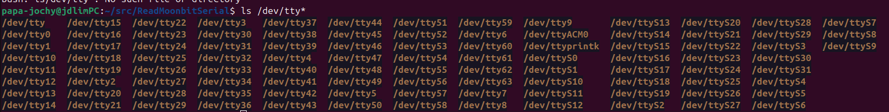

- identify microbit serial port linux

  - cat /sys/class/tty/ttyACM0/device/../idProduct
  - cat /sys/class/tty/ttyACM0/device/../idVendor
  - cat /sys/class/tty/ttyACM0/device/../manufacturer
  - cat /sys/class/tty/ttyACM0/device/../product
  - cat /sys/class/tty/ttyACM0/device/../serial
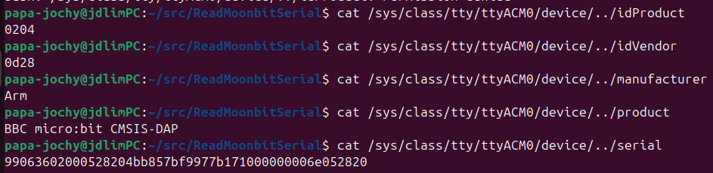

- dmesg serial usb device linux

sudo dmesg |grep tty
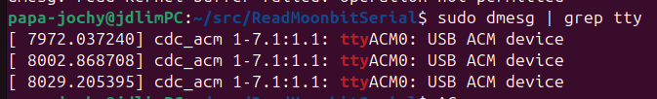

----------------------------------------------------

Part 2 – Flash Microbit with Serial Output Program

- Choose flashing method: MakeCode, Thonny, Mu (whichever you prefer)

I will be using MakeCode: working on ubutntu I will need to dwoload hex file manuall to microbit

- Write a Microbit program that:
  - Reads onboard temp & light sensors
Micorbit code that reads system temp and LDR sensor data completed and hex file added to ReadMoonbitSerial/makecode/ folder

  - Sends formatted string over serial
Added logic in makecode to send serial data back to the computer via usb for logging:
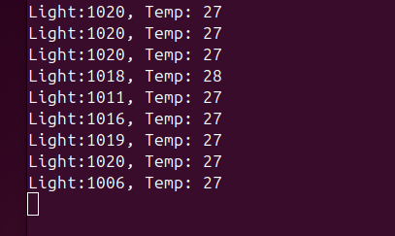

------------------------------------------------------------------------------------------------------

Part 3 – Read Serial Output in Python
- Created python script that reads serial port data coming for micro:bit, capturing 10 rows of light and temp data.
- It uses pyserial to save data into a list and clean up the data collected from the USB port /dev/ttyACM0
- code was less than 50 lines so only created a method to handle data clean up for saving to csv, don’t feel complexity warrants creating classes or separate files
----------------------------------------------------------------------------------------

Part 4 – Structure Project Repo
- Project structure cleaned up

-----------------------------------------------------------------------------------------------------

Part 5 – (Optional) CSV Logging or Graphing
- Created logs folder storing data collected into csv file Microbit Read Out.csv in that folder
- Used pandas data frames
- Graphing – will be done in future update

----------------------------------------------------------------------------------------------------

Part 6 – (Optional) Port to C++
- Will be done in future update

